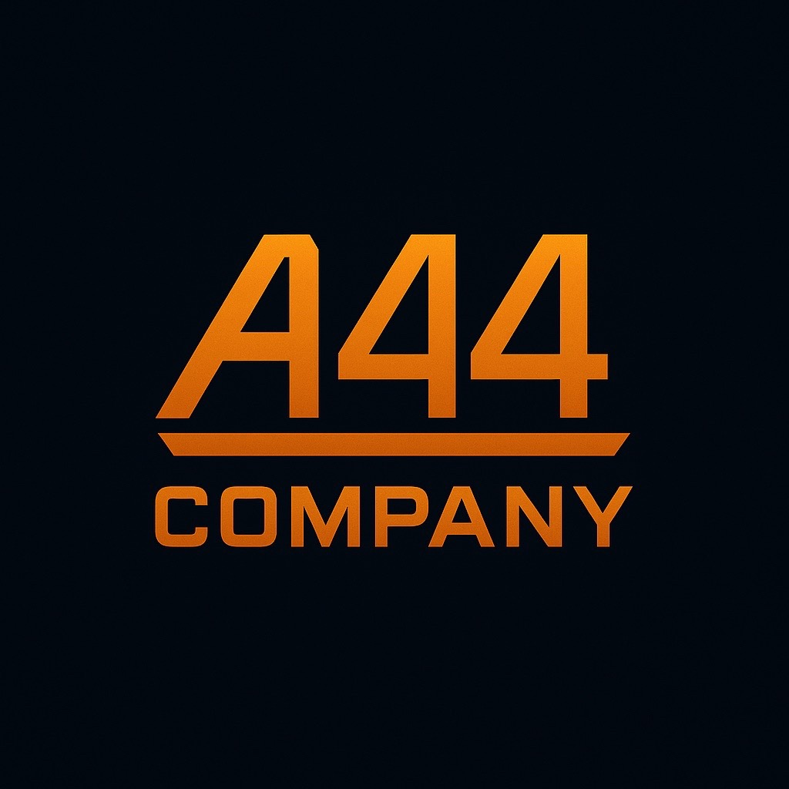

A44 COMPANY — Proposal
A44 Engineering & A44 Digital Solutions

Prepared For:
[Client Name]

Prepared By:
Ash Radford — Principal Consultant
Email: ash@A44Company.co.uk
Phone: 07305 281183
Website: A44Company.co.uk

Date:
[Insert Date]

1. Executive Summary
[Brief overview of the client challenge, A44’s understanding, and expected outcome.]

2. Scope of Work — A44 Engineering
[Engineering tasks, IQAN, HV traction, diagnostics, BMS, HMI, CAN/J1939, testing.]

3. Scope of Work — A44 Digital Solutions
[Full-stack dev, websites, AI tooling, automation, dashboards, internal tools.]

4. Deliverables
[List all deliverables here]

5. Project Timeline
[Timeline, phases, milestones.]

6. Pricing
A44 ENGINEERING:
• £100/hr remote engineering support
• £650–£750/day remote project work
• £900/day international on-site
A44 DIGITAL SOLUTIONS:
• £50–£65/hr standard development
• £350–£450/day digital project rate
• £65–£90/hr AI tooling & ChatGPT integrations

Fixed Price Options:
[Define fixed-price deliverables if applicable]

7. Assumptions & Dependencies
[Client responsibilities, assumptions, dependencies.]

8. Terms of Engagement (Summary)
[Short summary referencing full Terms of Engagement PDF.]

9. Acceptance
Client Signature: ________________________________
Name: _________________________________________
Date: __________________________________________
A44 Company Representative Signature: ________________________________
Name: Ashley Radford
Date: __________________________________________

